University of South Carolina Chapter of

Presents
Building a Successful Career in
Engineering & Computing:
Key Success Factors and Lessons Learned
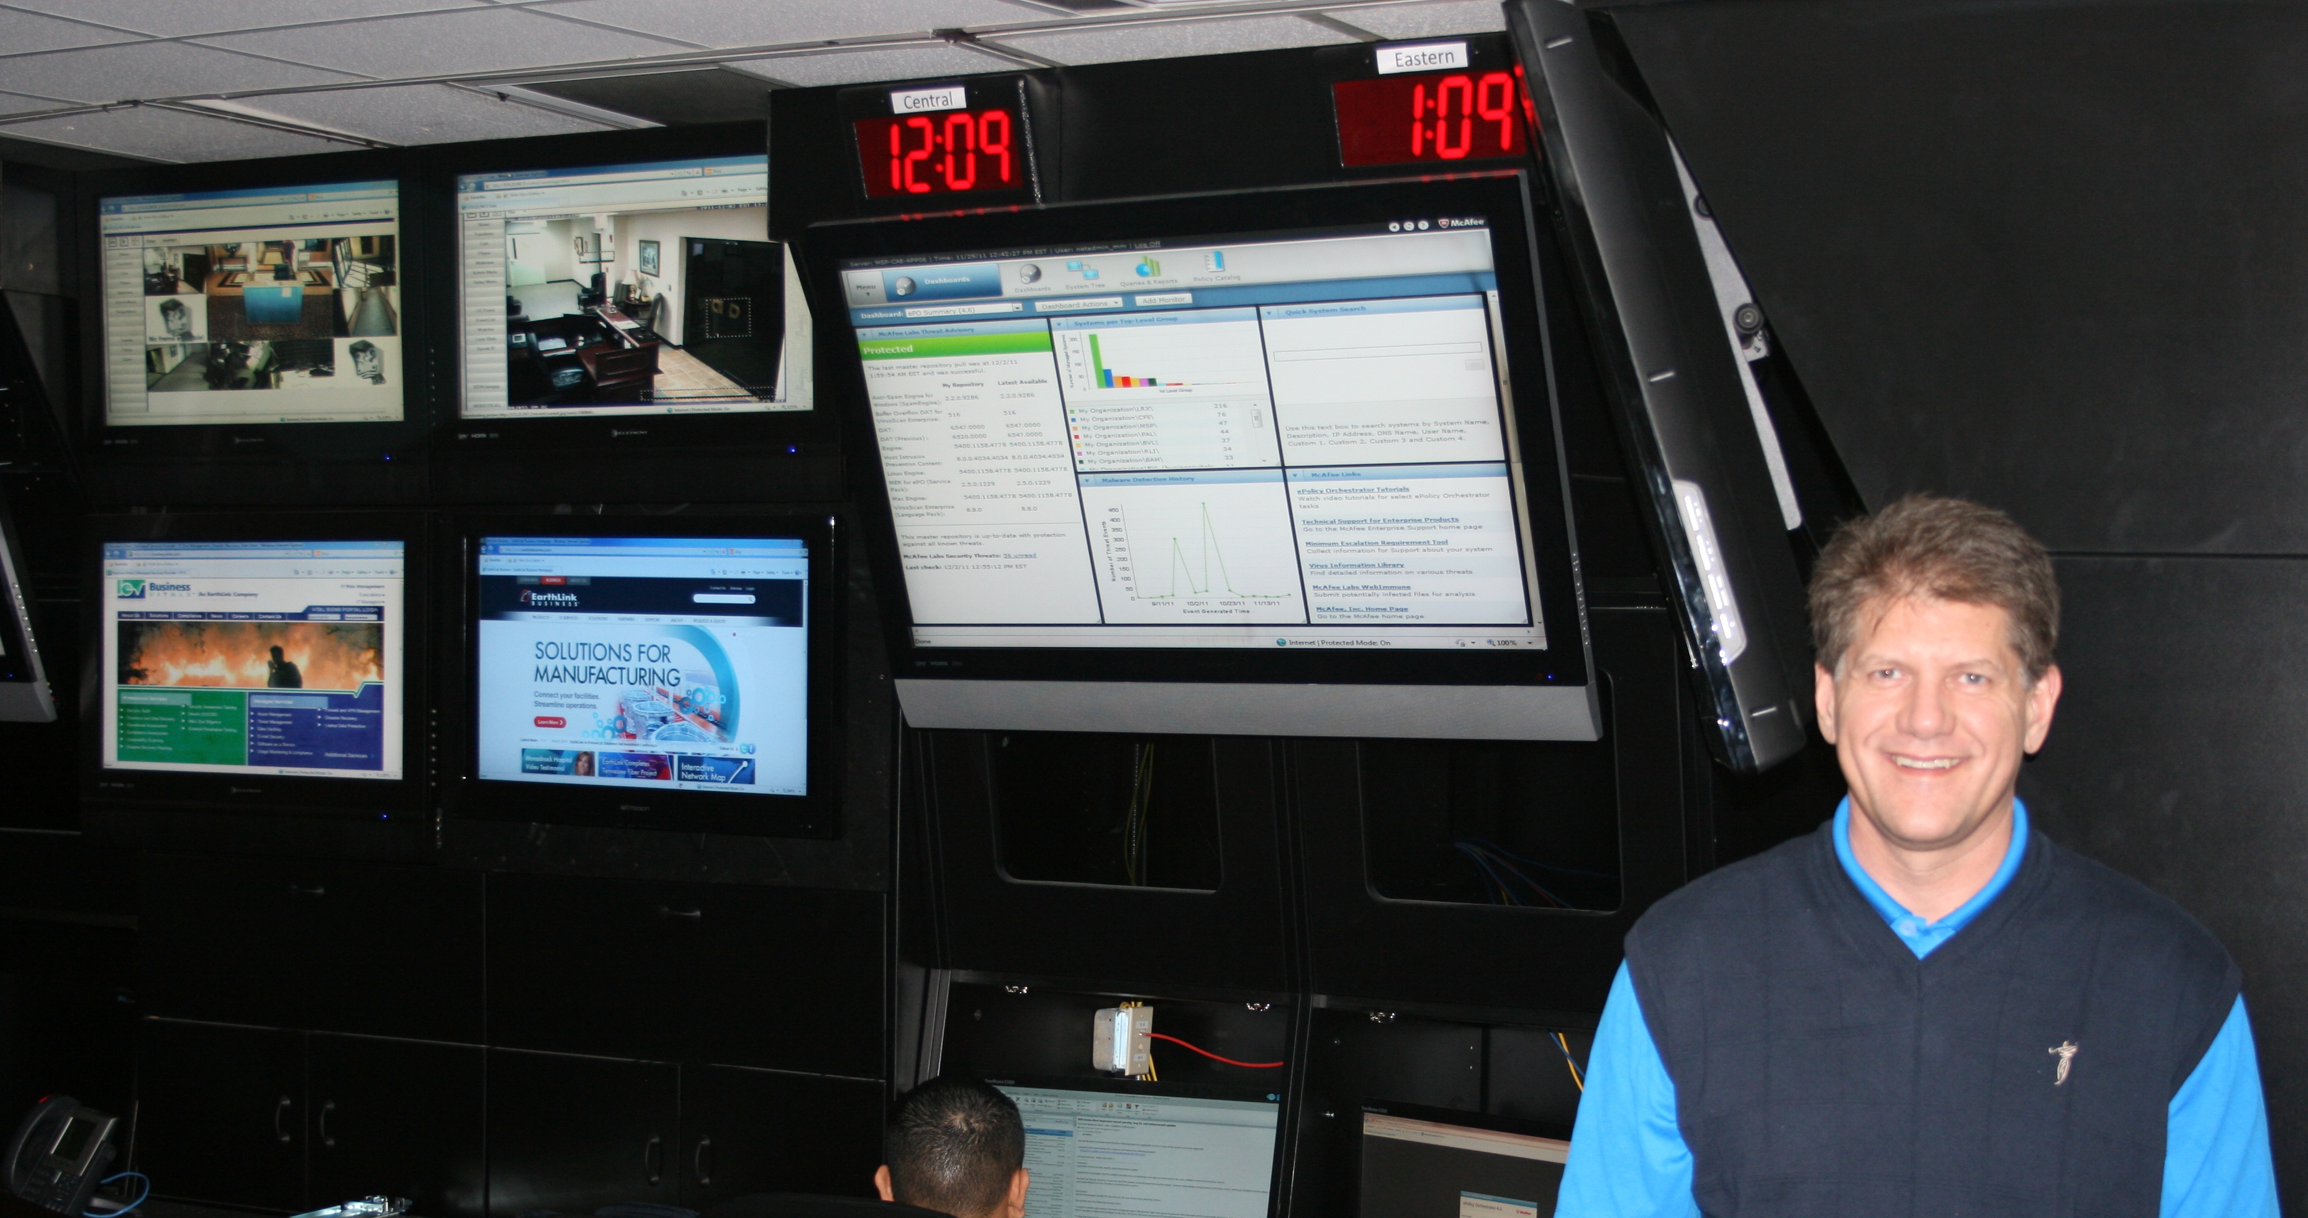
The UPE Keynote Address by
Jeff Brewer
4:00 PM
Wednesday, April 18, 2012
Faculty Lounge
Room 1A03, Swearingen Engineering Center

What does it take to build a successful career in the field of engineering & computing? Where do you start? Who can you learn from and what do you need to know to achieve success and enjoy your career to the fullest? There are many options for engineering and computing graduates today. Demand for capable talent has remained a constant regardless of the economic climate, so how can today’s graduates maximize their opportunities?
Jeff Brewer, a 1984 graduate of USC’s College of Engineering, was the founder of Business Vitals and is presently Vice President of Managed IT Services at Earthlink. He will share his insights, key success factors and lessons learned over the past 25 years working in industry and as a successful entrepreneur.
Sponsored by: The University of South Carolina Department of Computer Science and Engineering

